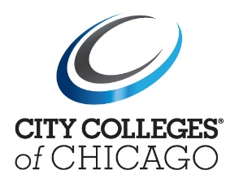

December 8th, 2021
ADDENDUM 2 for (RFP) #NG2102
ONLINE COURSE DEVELOPMENT AND INSTRUCTIONAL DESIGN SUPPORT
FOR THE DEPARTMENT OF ONLINE LEARNING

ONE (1) ORIGINAL SIGNATURE HARD COPY AND TWO (2) USB DRIVES OF THE RESPONSE TO BE SUBMITTED

All responses shall be addressed and returned to:
City Colleges of Chicago
Dawson Technical Institute
Procurement Services
3901 S. State Street, Room 102
Chicago, IL 60609
Attn: Nick Gibb – Associate Director of Procurement

Part I – Modifications to the RFP document

ITEM NO. 1 – CURRENTLY READS:

Proposals must be received no later than 12:00 p.m. CST, Monday, December 13th, 2021

CHANGE TO:
Proposals must be received no later than 12:00 p.m. CST, Tuesday, January 11th, 2022

Procurement Services is extending the due date for both the “Letter of Intent” submission (originally due Thursday, December 9th, 2021) and the complete RFP submission (originally due, Monday, December 13, 2021).

The new dates for submissions are as follows:

Letter of Intent: Due on or before – Tuesday, December 21st, 2021

Complete RFP submission package: Due on or before – Tuesday, January 11th, 2022
END OF ANNOUNCEMENT
Please acknowledge receipt of this announcement to
ngibb1@ccc.edu with a copy to procurementservices@ccc.edu

We are not accepting any additional questions.

