April 23, 2021

Tiffany Dixon
Vice President – Finance & Operations
1900 W. Jackson
Chicago, IL 60612

Dear Ms. Dixon,

HUB Parking Technology USA Inc. (HUB) satisfied the MBE/WBE requirements for the implementation and commissioning of the new Parking Access and Revenue Control System (PARCS) by utilizing MBE-qualified participants for the civil work component of the project. This particular type of work did not require the specialization of trained and certified HUB technicians.

However, the ongoing warranty and post-warranty maintenance service of the HUB equipment and software requires factory-trained HUB technicians who are certified to work on the system. HUB technicians are continuously trained on how to service the latest product releases and software upgrades. They have access to a worldwide network of HUB technicians for technical advice as is needed from time to time when problems occur.

Only HUB technicians are trained and authorized to effect repairs to the equipment and guarantee the work. An unauthorized person performing any service work will void any warranty.

For these reasons, HUB respectfully requests a waiver of the MBE/WBE requirements for the ongoing provision of services for post-warranty support and maintenance under the Technical Assistance and Maintenance Agreement.

Thank you for your consideration of this waiver request.
Please contact me if you have any questions.

Sincerely,
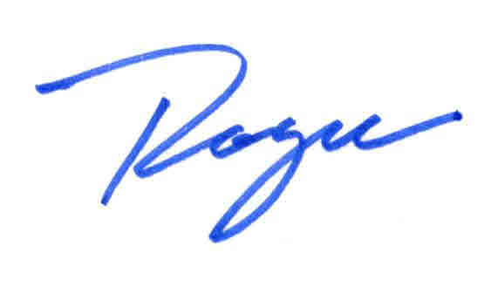
Roger Slayton
Director Business Development
Mobile: 412-303-5130
Office: 844-482-7275 X 5125

